Name: Sofia Aamir

Reg No: FA21-BSE-036

White Box Testing

Java Program to replace lower-case characters with upper-case and vice-versa

* Algorithm:

Here's the algorithm for converting lowercase characters to uppercase and uppercase characters to lowercase in a user input string:

* **Start:** Begin the algorithm.
* **Input:** Ask the user to input a word or sentence.
* **Read Input:** Read the input string from the user.
* **Initialize Variables:** Create a new string variable newStr to store the converted string.
* **Loop through Input String:** For each character in the input string:

If the character is a lowercase letter, convert it to uppercase and append it to newStr.

If the character is an uppercase letter, convert it to lowercase and append it to newStr.

If the character is not a letter, append it to newStr without any changes.

* **Output Result**: Print or display the converted string newStr.
* **End:** End the algorithm.
* Code:

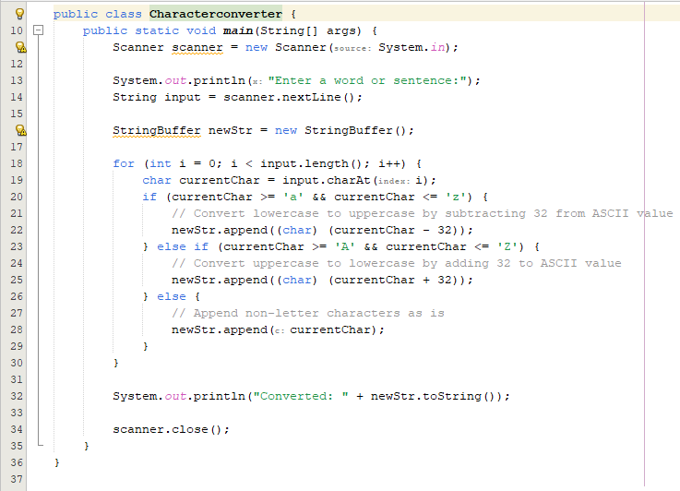

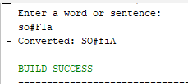



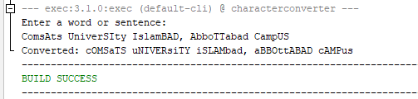

* Control Flow Graph:

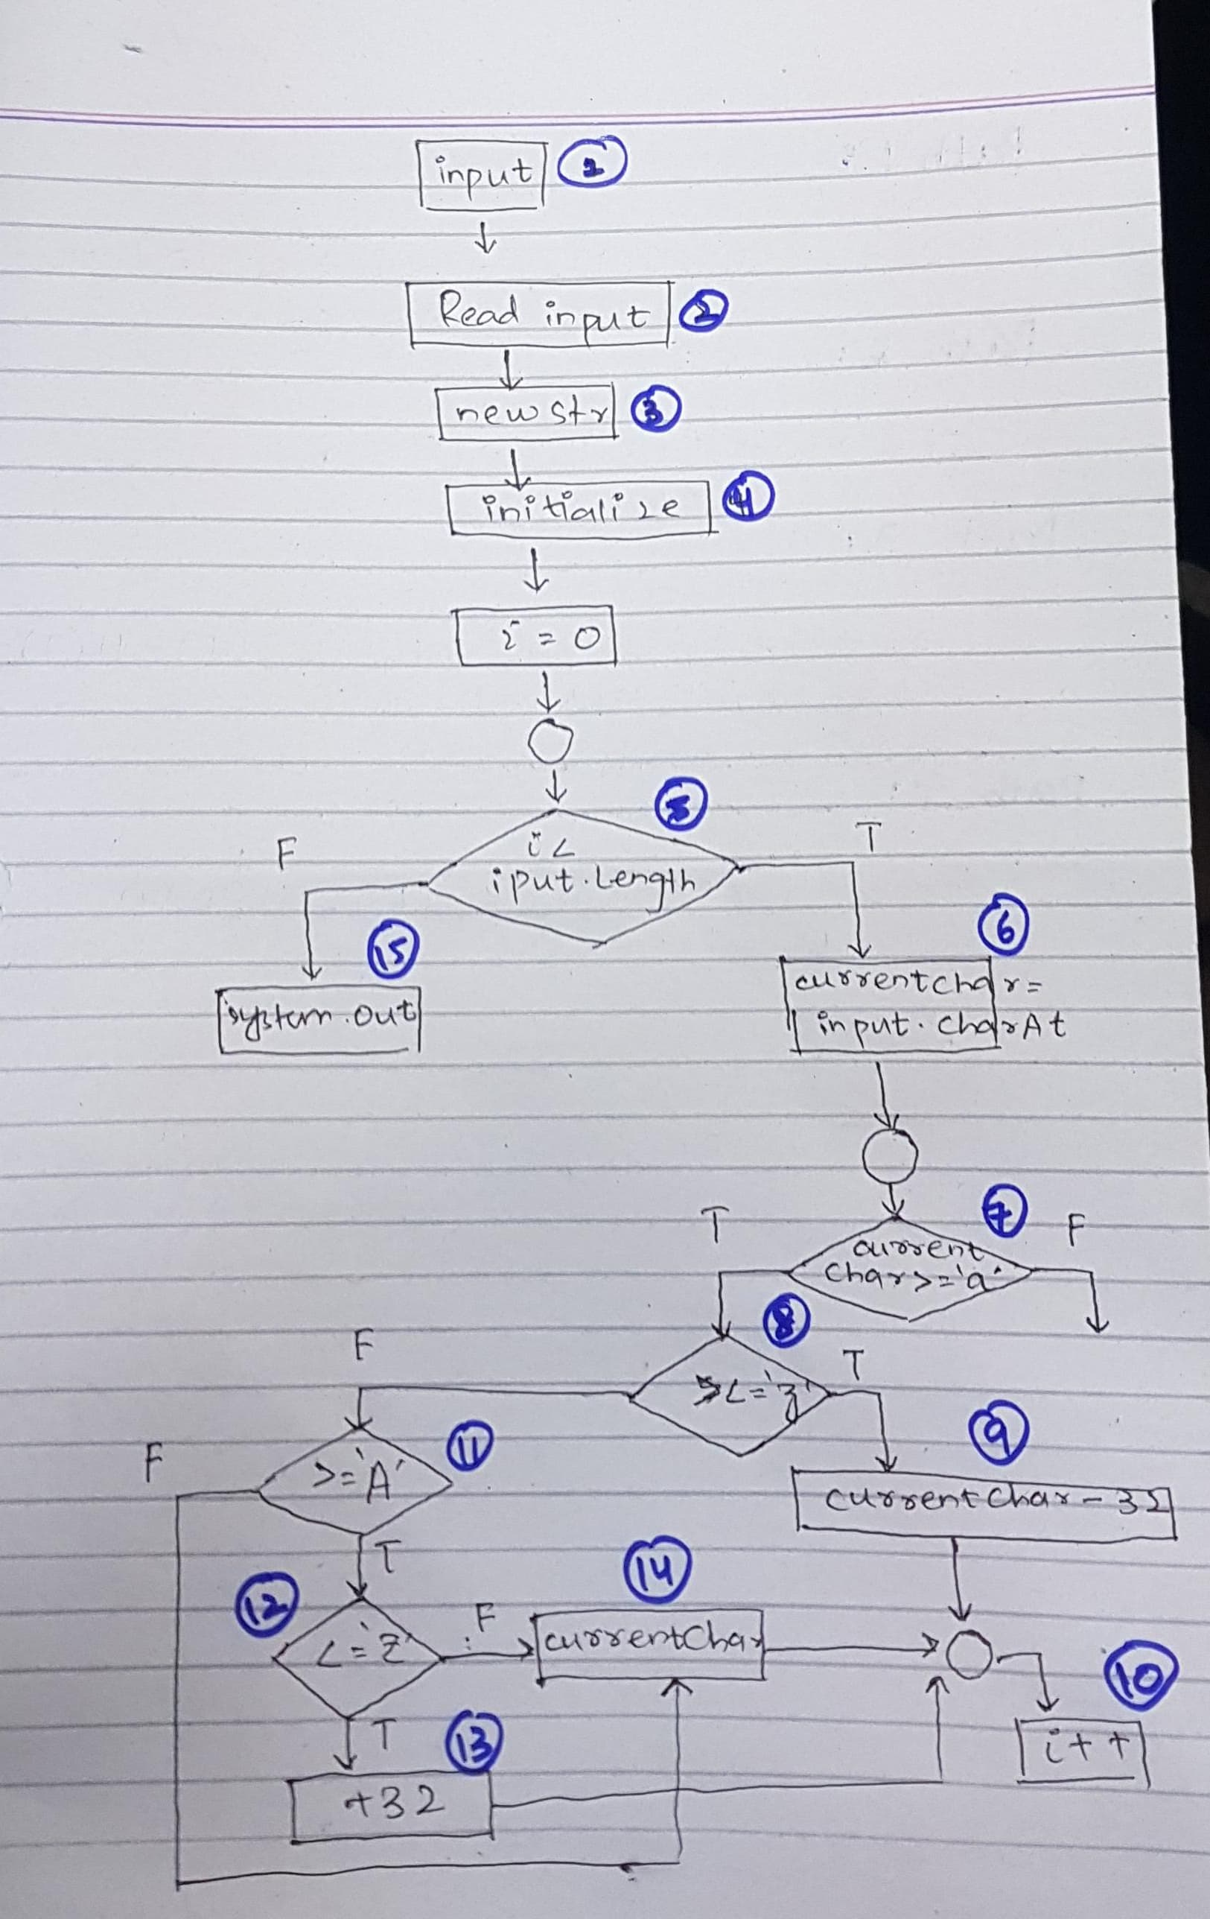

* Paths:

**Path 1:** 1-2-3-4-5(T)-6-7(T)-8(T)-9-10

**Path 2:** 1-2-3-4-5(F)-15

**Path 3:** 1-2-3-4-5(T)-6-7(T)-8(F)-11(T)-12(T)-13-10

**Path 4:** 1-2-3-4-5(T)-6-7(F)-11(F)-14-10

* Test Cases:

|  |  |  |  |  |  |
| --- | --- | --- | --- | --- | --- |
| **Test ID** | **Description** | **Test Data** | **Actual Result** | **Expected Result** | **Verdict** |
| **1** | Lowercase to Uppercase | Input: "Hello World" | hELLO wORLD | hELLO wORLD | Pass |
| **2** | No letters | Input: "12345" | 12345 | 12345 | Pass |
| **3** | Special characters | Input: "!@#$%" | !@#$% | !@#$% | Pass |
| **4** | Uppercase to Lowercase | Input: "AbCdEfG" | aBcDeFg | aBcDeFg | Pass |
| **5** | Lowercase to Uppercase | Input: "aBcDeFg" | AbCdEfG | AbCdEfG | Pass |
| **6** | Mixed case | Input: "Java Programming" | jAVA pROGRAMMING | jAVA pROGRAMMING | Pass |
| **7** | Mixed case | Input: "UPPER lower" | upper LOWER | upper LOWER | Pass |
| **8** | Mixed case and special characters | Input: "123abc!@#" | 123ABC!@# | 123ABC!@# | Pass |
| **9** | Mixed case | Input: "HeLlO" | hElLo | hElLo | Pass |
| **10** | Mixed case | Input: "the QUICK brown FOX" | THE quick BROWN fox | THE quick BROWN fox | Pass |